 

A Project Report on

NEWS PORTAL SYSTEM

Submitted in partial fulfillment of requirements for the award of the course of

**EGB1201 – JAVA PROGRAMMING**

Under the guidance of

## Ms. Hema R., M.E.,

**Assistant Professor / Information Technology**

Submitted By

**KEERTHIGA T (2303811710622052)**

**DEPARTMENT OF ELECTRONICS AND COMMUNICATION ENGINEERING**

# K. RAMAKRISHNAN COLLEGE OF TECHNOLOGY

(Autonomous)

**TRICHY - 621112**

DECEMBER 2024

# K. RAMAKRISHNAN COLLEGE OF TECHNOLOGY

**(Autonomous Institution affiliated to Anna University, Chennai)**

**TRICHY - 621112**

**BONAFIDE CERTIFICATE**

Certified that this project report on **“NEWS PORTAL SYSTEM”** is the Bonafide work of **KEERTHIGA T (2303811710622052)** who carried out the project work during the academic year 2024 - 2025 under my supervision.

Signature Signature

**Ms. HEMA R., M.E., Dr. SYEDAKBAR S., M.E.,Ph.D.,**

**SUPERVISOR, HEAD OF THE DEPARTMENT,**

Department of Information Technology, Department of ECE,

K. Ramakrishnan College of Technology, K. Ramakrishnan College of Technology, Trichy - 621112 Trichy – 621112



**DEPARTMENT OF ELECTRONICS AND COMMUNICATION ENGINEERING**

**VISION OF THE INSTITUTION**

To emerge as a leader among the top institutions in the field of technical education

**MISSION OF THE INSTITUTION**

* Produce smart technocrats with empirical knowledge who can surmount the global challenges
* Create a diverse, fully-engaged, learner-centric campus environment to provide quality education to the students
* Maintain mutually beneficial partnerships with our alumni, industry, and Professional associations

**VISION OF THE DEPARTMENT**

To create innovative and socially responsible Electronics and Communication Engineers with design skills and research focus to meet Societal and Industrial needs.

**MISSION OF THE DEPARTMENT**

* + M1: To provide high quality education and professional ethics to students through enhanced learning environment
  + M2: To impart a creative environment towards centre of excellence in department with design skill and exposure for research.
  + M3: To nurture required employable skills of students to satisfy the industry and social needs with ethical and human values.

**PROGRAM EDUCATIONAL OBJECTIVES (PEOS)**

* + PEO1: Core Knowledge Development: Graduates will have enhanced engineering skills in the field of electronics, communication and interdisciplinary areas to serve the society with global standards.
  + PEO2: Professional development: Graduates will apply the technical knowledge for continuous up gradation of their professional skills to become an inimitable employee, researcher or entrepreneur.
  + PEO3: Analytical Thinking: Graduates will have analytic and thinking skills to provide the innovative solutions for industry and societal requirements.

**PROGRAM OUTCOMES**

Engineering students will be able to:

1. **Engineering knowledge:** Apply the knowledge of mathematics, science, engineering fundamentals, and an engineering specialization to the solution of complex engineering problems.
2. **Problem analysis:** Identify, formulate, review research literature, and analyze complex engineering problems reaching substantiated conclusions using first principles of mathematics, natural sciences, and engineering sciences.
3. **Design/development of solutions:** Design solutions for complex engineering problems and design system components or processes that meet the specified needs with appropriate consideration for the public health and safety, and the cultural, societal, and environmental considerations.
4. **Conduct investigations of complex problems:** Use research-based knowledge and research methods including design of experiments, analysis and interpretation of data, and synthesis of the information to provide valid conclusions.
5. **Modern tool usage:** Create, select, and apply appropriate techniques, resources, and modern engineering and IT tools including prediction and modelling to complex engineering activities with an understanding of the limitations.
6. **The engineer and society:** Apply reasoning informed by the contextual knowledge to assess societal, health, safety, legal and cultural issues and the consequent responsibilities relevant to the professional engineering practice.
7. **Environment and sustainability:** Understand the impact of the professional engineering solutions in societal and environmental contexts, and demonstrate the knowledge of, and need for sustainable development.
8. **Ethics:** Apply ethical principles and commit to professional ethics and responsibilities and norms of the engineering practice.
9. **Individual and team work:** Function effectively as an individual, and as a member or leader in diverse teams, and in multidisciplinary settings.
10. **Communication:** Communicate effectively on complex engineering activities with the engineering community and with society at large, such as, being able to comprehend and write effective reports and design documentation, make effective presentations, and give and receive clear instructions.
11. **Project management and finance:** Demonstrate knowledge and understanding of the engineering and management principles and apply these to one’s own work, as a member and leader in a team, to manage projects and in multidisciplinary environments.
12. **Life-long learning:** Recognize the need for, and have the preparation and ability to engage in independent and life-long learning in the broadest context of technological change.

**PROGRAM SPECIFIC OUTCOMES (PSOs)**

* + PSO1: To analyse, design and develop solutions by applying foundational concepts of electronics and communication engineering.
  + PSO2: To apply design principles and best practices for developing quality products for scientific and business applications.

# ABSTRACT

The Java-Based News Portal System is a desktop application designed to streamline the dissemination and management of news articles in a categorized format. Built using Java Swing, the system provides a user-friendly interface for both administrators and regular users.The system emphasizes simplicity and efficiency, ensuring a seamless experience for all users. The project serves as a foundational implementation for news portals, demonstrating core functionalities like user authentication, content management, and categorized viewing. It can be further expanded with additional features like article search, commenting, and multimedia integration.

## ABSTRACT WITH POs AND PSOs MAPPING

|  |  |  |
| --- | --- | --- |
| **ABSTRACT** | **Pos**  **MAPPED** | **PSOs**  **MAPPED** |
| 1. The creation of users and articles | **PO 1** | **3** |
| 2. Using tools like Eclipse/IntelliJ - Modern tool usage | **PO5,PO8** | **1** |
| 3. Students gain awareness of the social responsibility | **PO9,PO12,PO8** | **2** |

Note: 1- Low, 2-Medium, 3- High

**SUPERVISOR HEAD OF THE DEPARTMENT**

# TABLE OF CONTENTS

|  |  |  |
| --- | --- | --- |
| **CHAPTER**  **No.** | **TITLE** | **PAGE**  **No.** |
|  | **ABSTRACT** | vi |
| **1** | **INTRODUCTION** | 1 |
|  | 1.1 Objective | 1 |
|  | 1.2 Overview | 2 |
|  | 1.3 Java Programming concepts | 2 |
| **2** | **PROJECT METHODOLOGY** | 3 |
|  | 2.1 Proposed Work | 3 |
|  | 2.2 Block Diagram | 4 |
| **3** | **MODULE DESCRIPTION** | 5 |
|  | 3.1 Authenticator Module | 5 |
|  | 3.2 Admin Panel Module | 5 |
|  | 3.3 User Dashboard Module | 6 |
|  | 3.4 News Article Module | 6 |
|  | 3.5 Category Management Module | 7 |
| **4** | **RESULTS AND DISCUSSION** | 8 - 12 |
| **5** | **CONCLUSION** | 13 |
|  | **REFERENCES** | 14 |
|  | **APPENDIX** | 15 - 18 |

**CHAPTER 1** **INTRODUCTION**

The News Portal System is a desktop-based application developed using Java Swing. It is designed to provide users with an organized platform for accessing and managing categorized news articles. This system caters to two distinct user groups: administrators and regular users. While regular users can view and explore news articles by categories, administrators have the privilege to manage the articles, ensuring the content remains up-to-date and relevant.

## Objective

The primary objective of the News Portal System project is to develop a user-friendly, Java-based application that facilitates efficient management and consumption of news articles. The system aims to provide a centralized platform where users can easily browse and access news articles organized into predefined categories such as *Politics*, *Sports*, and *Technology*. It ensures secure access through a robust user authentication system that differentiates between regular users and administrators. Administrators are empowered with the ability to dynamically manage content by adding, editing, or removing articles within specific categories, ensuring that the information remains relevant and up-to-date.

Additionally, the system offers an intuitive and interactive graphical user interface (GUI) designed using **Java Swing**, making it easy for both users and administrators to navigate and interact with the platform. By organizing articles into well-defined categories, the system enhances the user experience, allowing readers to focus on their areas of interest. The project also lays the groundwork for scalability and extensibility, enabling future enhancements such as the addition of new categories, multimedia integration, or database connectivity for larger-scale implementations.

Overall, the News Portal System aims to deliver a simple yet effective solution for managing and consuming news content efficiently.

## Overview

This system showcases the integration of user authentication, role management, and GUI-based content navigation, making it a suitable base for developing more advanced news portals in the future.Demonstrate the practical application of Java Swing for developing desktop-based user interfaces with distinct user roles .

## Java Programming Concepts

* + - Object-Oriented Programming (OOP)[Encapsulation]

Encapsulation is a fundamental principle of OOP where data (fields) and the methods that operate on that data are bundled together within a class. In the News Portal System, encapsulation is demonstrated by creating classes such as User, Admin, and News Article.

* + - Event handling [Action Listener]

Event handling in Java is the mechanism that manages user interactions with GUI components like buttons, text fields, or combo boxes. In the News Portal System, ActionListener is used to handle button clicks and other user actions.

* + - Exception Handling [Basic validation]

Exception handling ensures that the program can gracefully handle unexpected events or errors, such as invalid input or missing data. In this basic input validation is implemented to prevent common issues

* + - Java Swing [GUI Framework]

Java Swing is the foundation of the graphical interface, enabling a visually

appealing and functional application.

# CHAPTER 2 PROJECT METHODOLOGY

## Proposed Work

The News Portal System is a proposed solution designed to provide an efficient platform for users to access categorized news articles and for administrators to manage content dynamically. The system ensures secure access through a robust registration and authentication mechanism, differentiating between regular users and administrators. Users can log in to access a user-friendly dashboard, where they can browse and view articles organized into predefined categories such as *Politics*, *Sports*, and *Technology*. The admin panel empowers administrators to manage news articles by adding or removing them within specific categories, ensuring content remains relevant and organized. Built using **Java Swing**, the graphical user interface (GUI) provides an intuitive experience with interactive components like dropdown menus, buttons, and text fields. The system incorporates basic validation to maintain data integrity, ensuring fields like login credentials and article titles are properly validated to prevent errors. While articles and user data are stored in memory for simplicity, the system is designed to be scalable, with potential for future enhancements such as multimedia integration, live news feeds, and database connectivity. By offering a dynamic and interactive solution, the News Portal System simplifies news management and enhances user experience, making it a robust and engaging application.

* 1. **Block Diagram**

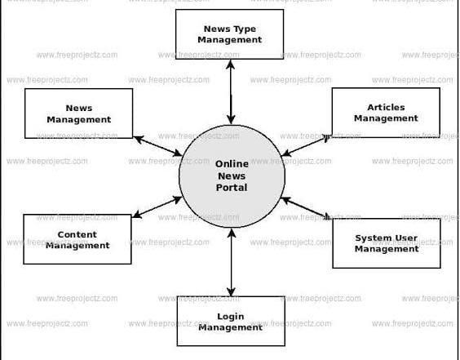

# CHAPTER 3 MODULE DESCRIPTION

## Authentication Module

The Authentication Module is responsible for managing user registration and login functionality, ensuring secure access to the system. This module allows users to create accounts by providing unique usernames and passwords, which are validated during login. It differentiates between regular users and administrators, providing role-based access to system features. User data is stored using a HashMap for simplicity, or a database can be integrated for enhanced scalability. Secure password validation and error handling mechanisms ensure reliable and smooth authentication, preventing unauthorized access or misuse. This module is critical for establishing user identities and protecting the system's integrity.

## Admin Panel Module

The Admin Panel Module empowers administrators with complete control over news content management. It enables administrators to add new articles to specific categories like *Politics*, *Sports*, or *Technology* and remove existing articles when no longer relevant. Administrators can also view all articles within a particular category to ensure the content remains organized and up-to-date. The module features an intuitive GUI for seamless interaction, with buttons and dropdowns simplifying article addition and removal.

## User Dashboard Module

The User Dashboard Module provides regular users with an interactive platform to browse and view news articles based on their interests. Users can select a category, such as *Politics*, *Sports*, or *Technology*, through a dropdown or navigation menu and view articles displayed in a scrollable text area. It dynamically updates the displayed articles based on the selected category, offering a personalized and engaging browsing experience. This module serves as the primary interface for readers to consume news efficiently.

## News Article Module

The News Article Module is the core component of the system, responsible for managing individual news articles and their associated attributes. Each article is represented as an object containing key details such as the article title, category, and content. This module ensures that articles are dynamically created, categorized, and stored within the system. The module interacts with the Category Management Module to organize articles within their respective categories and ensures that the content is readily accessible to users through the User Dashboard Module. Administrators can add new articles with a specified title and assign them to categories like *Politics*, *Sports*, or *Technology*. Similarly, articles can be removed or updated as needed.

## Category Management Module

The Category Management Module ensures that all news articles are organized into predefined categories for better accessibility. Categories such as *Politics*, *Sports*, and *Technology* are implemented using a HashMap<String, Array List<String>> structure, where each category maps to a list of associated articles. This module dynamically updates the stored articles when administrators add or remove content, maintaining consistency across the system. It includes a graphical user interface to display categories and their respective articles, providing both users and administrators with a seamless navigation experience.

 

# CHAPTER 4 RESULTS AND DISCUSSION

The News Portal System successfully demonstrates the integration of core Java concepts to deliver a functional and user-friendly application for managing and consuming news content. The system includes distinct modules for authentication, user interaction, and content management, all working together to provide a seamless experience for both users and administrators.

When you first run the application, you will see the **Login** screen . You can log in using the username admin and password admin for the admin panel, or you can register a new account as shown in fig 4.1.

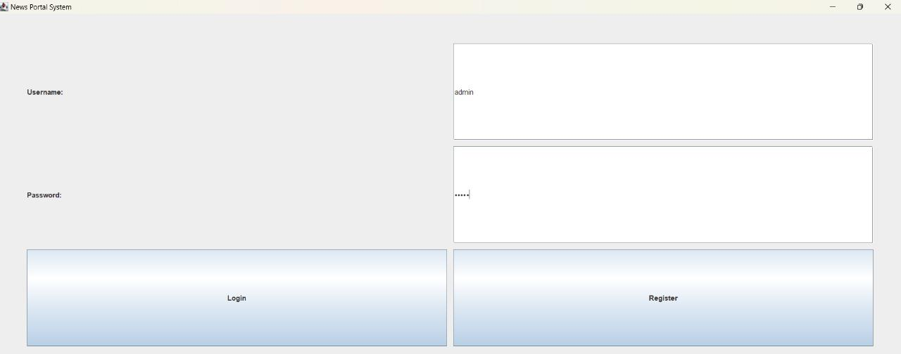

Fig : 4.1 Admin Panel



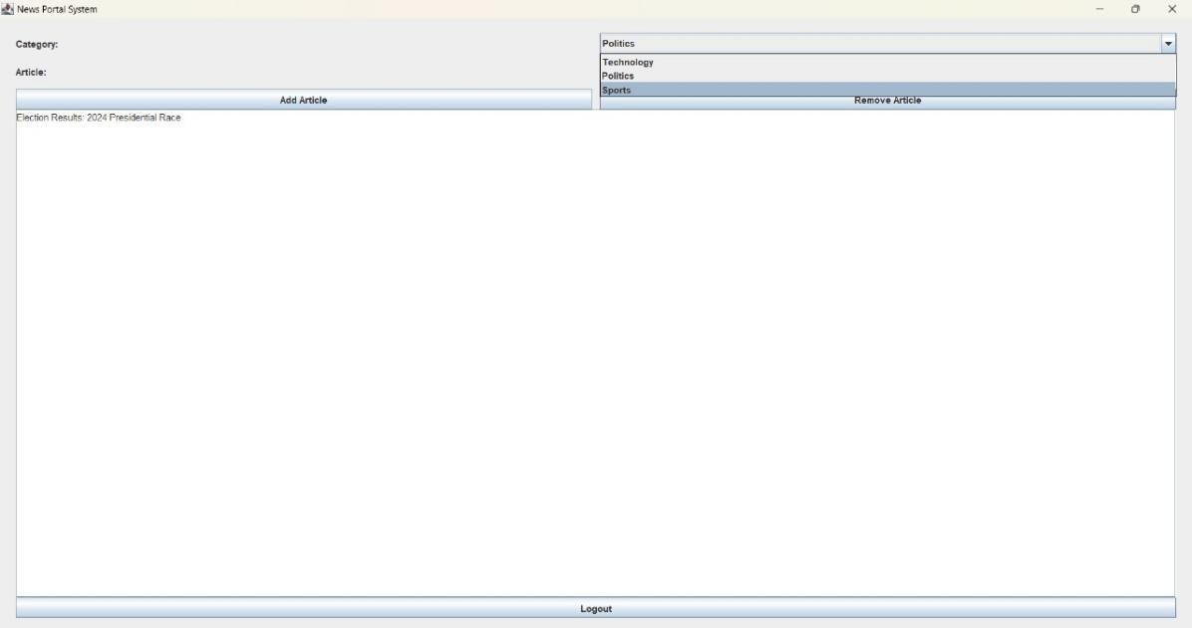

**Fig 4.2 Select the category**

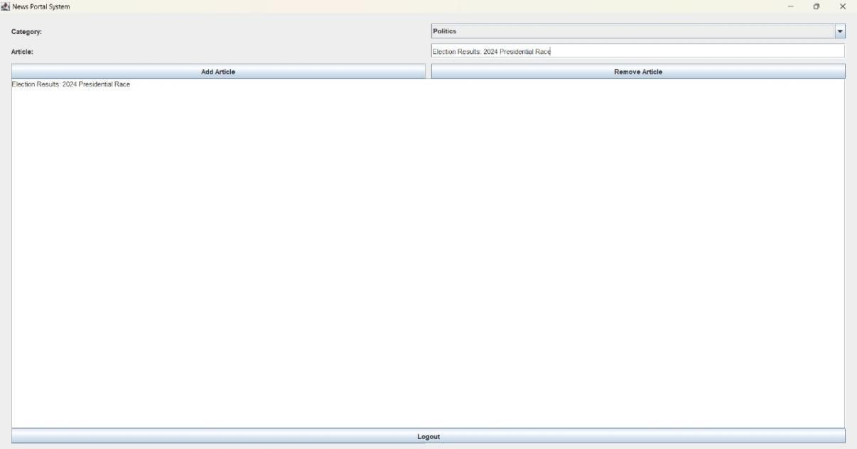

**Fig 4.3 Adding the article**

Articles will be listed under the selected category, admin can add or remove articles.

* + 1. Add an article: Enter "New Election Results" in the Article field and click Add Article. The article will be added to the Politics category.
    2. Remove an article: Select an article in the Article field and click Remove Article to remove it from the category.



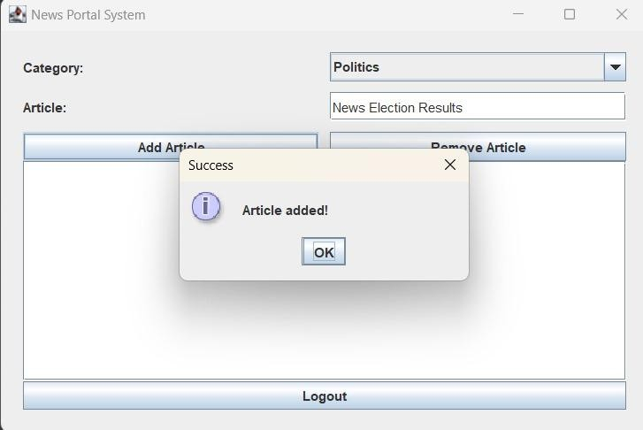

**Fig 4.4 Popup message of Article added**

This is same for both if you remove the Article it shows the popup message as “Article removed!”

To view the articles you have to register using the username and any password and click on register on the login screen.

If you click on **Register** in the Login screen, you will be taken to the **Register**

screen as shown in the fig 4.5.

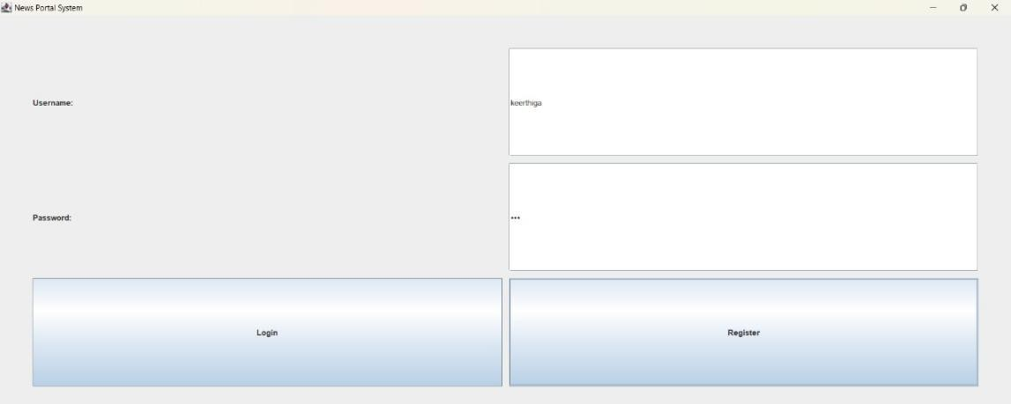

**Fig 4.5 Registration Page**

If you completed the registration it will shows the popup message as “Registered successfully!” as shown below fig 4.6.

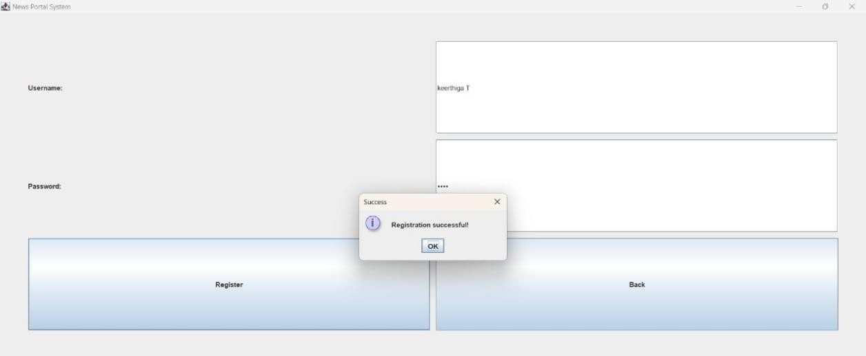

**Fig 4.6 Popup message of Registration successful**

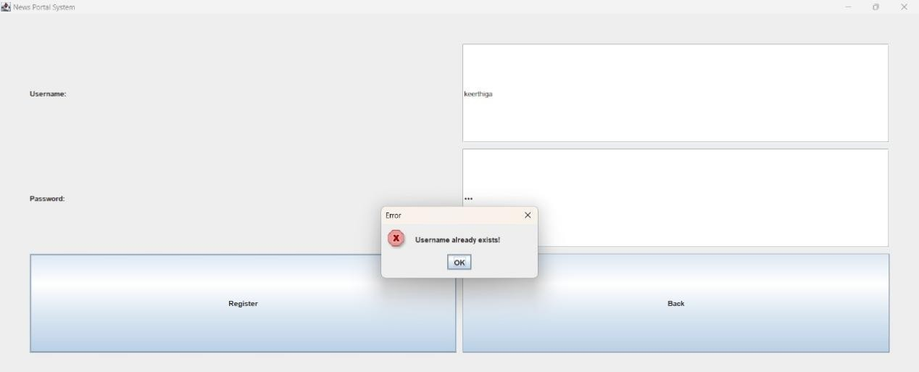

**Fig 4.7 Popup message**

When you register as the regular user logs in, they will be directed to the **User Dashboard.**

Then login using the registered username and password. After Login you will get in to the articles viewing page.you have to select the category and you can view the Articles by the listed categories.

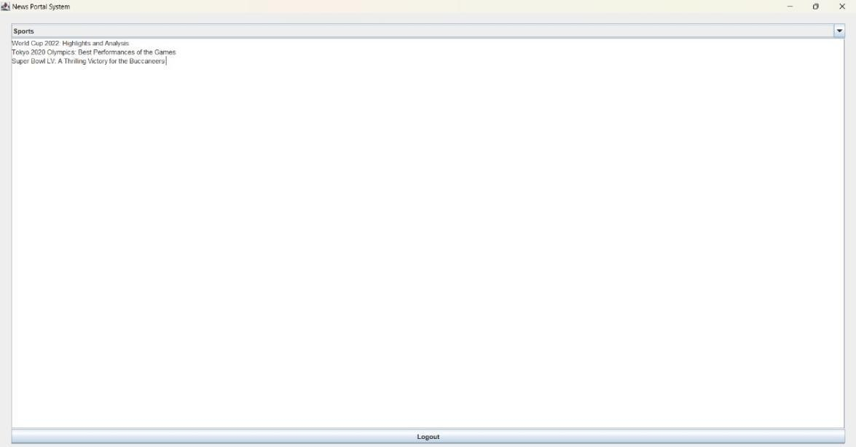

Fig 4.8 Article viewing Page

The project highlights the use of fundamental Java programming principles to create a modular and scalable application. The Authentication Module implements robust validation to handle login attempts securely. The Admin Panel ensures ease of news content management through a dynamic GUI, while the User Dashboard focuses on simplifying the content consumption process for end-users.



# CHAPTER 5 CONCLUSION

The News Portal System project successfully implements a Java-based application for managing and viewing news articles. By leveraging core Java concepts such as object-oriented programming (OOP), event handling, exception handling, and Java Swing for graphical user interfaces (GUIs), the system provides a user-friendly, secure, and efficient platform. The modular structure, including the Authentication Module, Admin Panel, User Dashboard, and Category Management, ensures a clear separation of concerns and makes the system scalable for future improvements.

The use of Java Swing ensures a rich graphical user interface, but it has some limitations in scalability compared to modern frameworks. For larger-scale applications, integrating a database for persistent data storage and retrieval would be more effective than the current in-memory data handling using HashMap. The modular structure of the system makes it adaptable for future enhancements, such as real-time updates, user personalization, or multimedia integration.

Overall, the News Portal System achieves its objectives by delivering an efficient, interactive, and easy-to-use platform for managing and accessing categorized news articles. The project demonstrates the practicality of applying Java concepts to solve real-world problems in a structured and organized manner.

**REFERENCES**

1. "Java: The Complete Reference" by Herbert Schildt.
2. "Core Java Volume I - Fundamentals" by Cay S. Horstmann.
3. "Head First Java" by Kathy Sierra and Bert Bates.
4. GeeksforGeeks - Java Programming Language. Link: <https://www.geeksforgeeks.org/java/>
5. Java Programming Tutorials by Programming with Mosh. Link: <https://www.youtube.com/c/programmingwithmosh>

import javax.swing.*; import java.awt.*; import java.awt.event.*;

import java.util.ArrayList; import java.util.HashMap;

# APPENDIX

**(Coding)**

public class NewsPortalSystem {

private HashMap<String, String> users = new HashMap<>();

private HashMap<String, ArrayList<String>> articles = new HashMap<>(); private JFrame frame;

private CardLayout cardLayout; private JPanel mainPanel;

public NewsPortalSystem() { articles.put("Politics", new ArrayList<>()); articles.put("Sports", new ArrayList<>()); articles.put("Technology", new ArrayList<>()); users.put("admin", "admin");

frame = new JFrame("News Portal"); cardLayout = new CardLayout(); mainPanel = new JPanel(cardLayout);

mainPanel.add(createLoginPanel(), "Login"); mainPanel.add(createRegisterPanel(), "Register"); mainPanel.add(createAdminPanel(), "Admin"); mainPanel.add(createUserPanel(), "User");

frame.add(mainPanel); frame.setSize(600, 400);

frame.setDefaultCloseOperation(JFrame.EXIT_ON_CLOSE); frame.setVisible(true);

}

private JPanel createLoginPanel() {

JPanel panel = new JPanel(new GridLayout(3, 2, 10, 10));

JTextField txtUsername = new JTextField(); JPasswordField txtPassword = new JPasswordField();

JButton btnLogin = new JButton("Login"), btnRegister = new JButton("Register"); btnLogin.addActionListener(e -> {

if (users.containsKey(txtUsername.getText()) && users.get(txtUsername.getText()).equals(new String(txtPassword.getPassword()))) {

cardLayout.show(mainPanel, txtUsername.getText().equals("admin") ? "Admin" :

"User");

} else JOptionPane.showMessageDialog(frame, "Invalid credentials", "Error", JOptionPane.ERROR_MESSAGE);

});

btnRegister.addActionListener(e -> cardLayout.show(mainPanel, "Register")); panel.add(new JLabel("Username:")); panel.add(txtUsername);

panel.add(new JLabel("Password:")); panel.add(txtPassword); panel.add(btnLogin); panel.add(btnRegister);

return panel;

}

private JPanel createRegisterPanel() {

JPanel panel = new JPanel(new GridLayout(3, 2, 10, 10));

JTextField txtUsername = new JTextField(); JPasswordField txtPassword = new JPasswordField();

JButton("JButton btnRegister = new JButton("Register"), btnBack = new Back");

btnRegister.addActionListener(e -> {

if (users.containsKey(txtUsername.getText())) { JOptionPane.showMessageDialog(frame, "Username exists", "Error",

JOptionPane.ERROR_MESSAGE);

} else {

users.put(txtUsername.getText(), new String(txtPassword.getPassword())); cardLayout.show(mainPanel, "Login");

}

});

btnBack.addActionListener(e -> cardLayout.show(mainPanel, "Login")); panel.add(btnRegister); panel.add(btnBack);

return panel;

}

private JPanel createAdminPanel() {

JPanel panel = new JPanel(new BorderLayout());

JComboBox<String> categoryBox = new JComboBox<>(articles.keySet().toArray(new String[0]));

JTextField txtArticle = new JTextField(); JTextArea txtDisplay = new JTextArea(); txtDisplay.setEditable(false);

JButton btnAdd = new JButton("Add"), btnRemove = new JButton("Remove"), btnLogout

= new JButton("Logout");

btnAdd.addActionListener(e -> {

if (!txtArticle.getText().isEmpty()) { articles.get(categoryBox.getSelectedItem()).add(txtArticle.getText()); updateDisplay(categoryBox, txtDisplay); txtArticle.setText("");

}

});

btnRemove.addActionListener(e -> {

if (articles.get(categoryBox.getSelectedItem()).remove(txtArticle.getText())) {

updateDisplay(categoryBox, txtDisplay); txtArticle.setText("");

}

});

btnLogout.addActionListener(e -> cardLayout.show(mainPanel, "Login")); panel.add(categoryBox, BorderLayout.NORTH);

panel.add(new JScrollPane(txtDisplay), BorderLayout.CENTER); panel.add(btnLogout, BorderLayout.SOUTH);

return panel;

}

private JPanel createUserPanel() {

JPanel panel = new JPanel(new BorderLayout());

JComboBox<String> categoryBox = new JComboBox<>(articles.keySet().toArray(new String[0]));

JTextArea txtDisplay = new JTextArea(); txtDisplay.setEditable(false); JButton btnLogout = new JButton("Logout"); btnLogout.addActionListener(e -> cardLayout.show(mainPanel, "Login"));

categoryBox.addActionListener(e -> updateDisplay(categoryBox, txtDisplay)); panel.add(categoryBox, BorderLayout.NORTH);

panel.add(new JScrollPane(txtDisplay), BorderLayout.CENTER); panel.add(btnLogout, BorderLayout.SOUTH);

return panel;

}

private void updateDisplay(JComboBox<String> categoryBox, JTextArea txtDisplay) { String category = (String) categoryBox.getSelectedItem(); txtDisplay.setText(String.join("\n", articles.get(category)));

}

public static void main(String[] args) { SwingUtilities.invokeLater(NewsPortalSystem::new);

}

}